**Week 8**

**Aim:** Computing and plotting the coefficient of correlation and the regression lines.

**Problem Statement:**

1. The heights of father and sons are given below. Find coefficient of correlation (Pearson and Spearman) and regression lines Also, plot the lines.

Heights of father (in inches): 65,63,67,64,68,62,70,66,68,67,69,71) Heights of sons (in inches): (68,66,68,65,69,66,68,65,71,67,68,70)

1. Find coefficient of correlation (Pearson and Spearman) and regression lines, also plot the lines.

X: (175,158,170,171,159,165,165160,180,186)

Y: (180,168,177,175,170,165,167,160,185,190)

**Code:**

**1.**

x1<-c(65,63,67,64,68,62,70,66,68,67,69,71)

y1<-c(68,66,68,65,69,66,68,65,71,67,68,70)

df<-data.frame(x1,y1)

rp=cor(df)

plot(df)

reg.xy=lm(x1~y1,data=df)

reg.yx=lm(y1~x1,data=df)

plot(df,main='regression lines')

abline(reg.xy,col='red')

abline(reg.yx,col='green')

rp

**2.**

x1<-c(175,158,170,171,159,165,165,160,180,186)

y1<-c(180,168,177,175,170,165,167,160,185,190)

df<-data.frame(x1,y1)

rp=cor(df)

plot(df)

reg.xy=lm(x1~y1,data=df)

reg.yx=lm(y1~x1,data=df)

plot(df,main='regression lines')

abline(reg.xy,col='red')

abline(reg.yx,col='green')

rp

**Output:**

**1.**

**x1** **y1**

x1 1.0000000 0.7026516

y1 0.7026516 1.0000000

**2.**

**x1** **y1**

x1 1.0000000 0.9207994

y1 0.9207994 1.0000000

**Graph:**

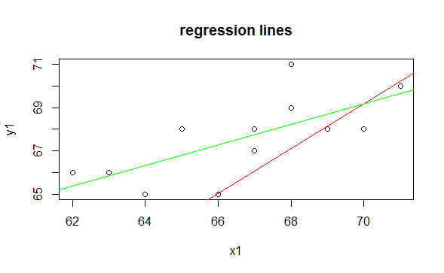

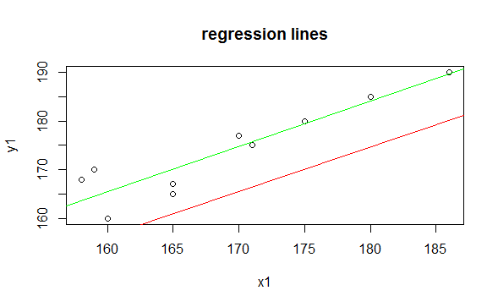

**Result:**

The Coefficient of correlation and regression lines were successfully computed and plotted.